Project Design Phase-II Technology Stack (Architecture & Stack)

|  |  |
| --- | --- |
| Date | 11 October 2022 |
| Team ID | PNT2022TMID20449 |
| Project Name | Project –Smart Farmer-IoT enabled smart farming application. |
| Maximum Marks | 4 Marks |

Technical Architecture:

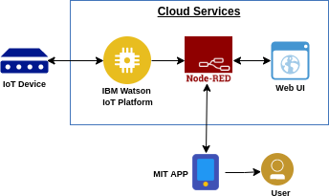

Table-1 : Components & Technologies:

|  |  |  |  |
| --- | --- | --- | --- |
| **S.No** | **Component** | **Description** | **Technology** |
| 1. | User Interface | How user interacts with application e.g.  Web UI, Mobile App, Chat bot etc. | MIT app |
| 2. | Application Logic-1 | Logic for a process in the application | Node red/IBM Watson/MIT app |
| 3. | Application Logic-2 | Logic for a process in the application | Node red/IBM Watson/MIT app |
| 4. | Application Logic-3 | Logic for a process in the application | Node red/IBM Watson/MIT app |
| 5. | Database | Data Type, Configurations etc. | MySQL, NoSQL, etc. |
| 6. | Cloud Database | Database Service on Cloud | IBM cloud. |
| 7. | Temperature sensor | Monitors the temperature |  |
| 8. | Humidity sensor | Monitors the humidity |  |

|  |  |  |  |
| --- | --- | --- | --- |
| 9. | Soil moisture sensor | Monitors the soil temperature |  |
| 10. | Weather sensor | Monitors the weather | . |
| 11. | PH sensor | Monitors the PH of the soil | . |
| 12. | RTC module | Date and time configuration |  |
| 13. | Relay | To get the soil moisture data |  |
| 14. | External API 1 | To get the real time values of Humidity, Temperature and Moisture. | Open Weather API. |

Table-2: Application Characteristics:

|  |  |  |  |
| --- | --- | --- | --- |
| **S.No** | **Characteristics** | **Description** | **Technology** |
| 1. | Open-Source Frameworks | MIT app, Node-Red | Software |
| 2. | Scalable Architecture | Drone technology, pesticide monitoring ,Mineral identification in soil | Hardware |